Our typical school day

Our names are Terri and Kira. On a typical school day we get up at 7:15. when we are up we have our breakfast and get ready for school. Our school uniform includes white shirt, navy blue jumper, black trousers and school shoes.

We leave our houses at 8:10 am. We always meet our friends on the way to school. Our friends are:
☺Tia
☺Jennie
☺Natasha
school starts at 8:55 am and then our lessons begin.

Our first lesson on a morning is Maths. This lesson lasts for 1 hour. We think maths is totally boring. Our maths teacher is called Mr Holden. After maths we have our break where we can play games and eat some food.

Our second lesson is English. This lesson lasts for 1 hour. Miss Goddard teaches us English. We both enjoy English when we get to write stories and poems. After English we have our lunch. This is a chance to talk to friends and eat our lunch.

In the afternoon we have theme work. This is when we create a folder of our best ability. In our folders there are all the subjects we learn in one book.

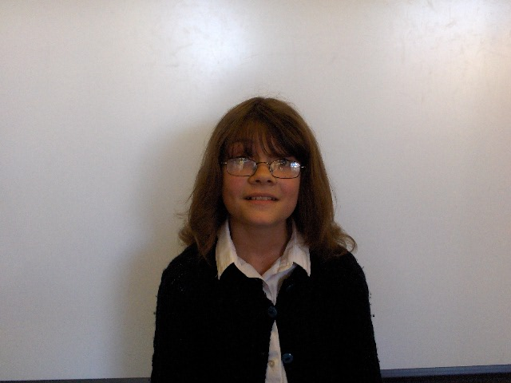
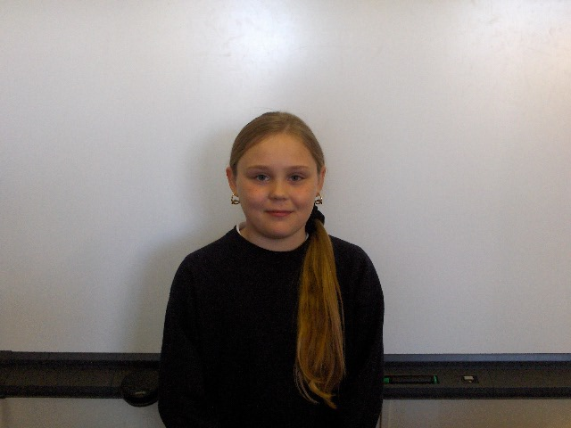
We finish school at 3:15 and walk home with either our parents or friends.

Kira

X☺X

Terri ☺

